DEPARTMENT OF COMPUTER SCIENCE AND ENGINEERING
Date: 26.04.2021
EVENT SUMMARY REPORT
Organization | Mall Reddy Engineering College (Autonomous)
Department | CSE |  | Professional Body |  |  | Institutional Body
Nature of the Event | Trend in Technology
Title /Theme of the Event | An online Guest lecture on DevOps using Cloud
Details of the Co-ordinators & Designation | Dr. Shaik. Jakeer Hussain, Associate Professor, CSE
Event Date/Days | From |  |  | To |  |  | No. of Days
 | 24.04.2021 |  |  | 24.04.2021 |  |  | 1 Day
Details of the Speaker/Guest  Organization/Address | Mr. B. Abhilash Reddy, Senior DevOps Engineer, Infosys
Participants(Students(UG & PG)/Teaching Faculty/Non-Teaching Faculty | No .of Faculty | No. of UG Students |  |  | No. of PG Students | No. of Outside Participants |  | Total Participants
 | - | 475 |  |  | - | - |  | 475
Faulty Names & Designation | Mr. A. Nagaraju, Assistant professor, CSE
Summary of the Event | In this lecture the following topics are covered -DevOps Model Defined, How DevOps Works, Benefits of DevOps, Why DevOps Matters, How to Adopt a DevOps Model and DevOps Practices.  DevOps is the new development that addresses such inefficiencies. It connects development, quality assurance, and technical operations personnel in a way that the entire ‘build-release-run-repeat’ process operates as a factory, having clear roles and responsibilities and well-defined inputs and outputs.  The aim of DevOps is to revolutionize the transition, de-risk IT deployments, eliminate the excuse “but-it-works-on-my-system”, and break the silos between developers, testers, release managers, and system operators. The products and tools developed in this area focus on maximizing predictability, visibility, and flexibility, while maintaining stability and integrity.  DevOps is an ‘old’ approach understood and discussed by a relatively small number of professionals. To master it, companies must apply a much more holistic approach. With the advent of new technologies and growing demand for faster processes and better quality, DevOps has acquired new dimensions. Organizations across the globe have been implementing a full or partial DevOps solution. However, the road to DevOps is not straight. DevOps is a complex concept with no clear definition or list of products. It lacks a common vocabulary and capabilities required for DevOps implementation differ from one environment to the other.  To get maximum benefit from the DevOps implementation, we recommend focus on three key areas - change of culture, connection of processes, and common tooling. This is crucial to reduce development-to-operations costs and minimize change related outages.
 | 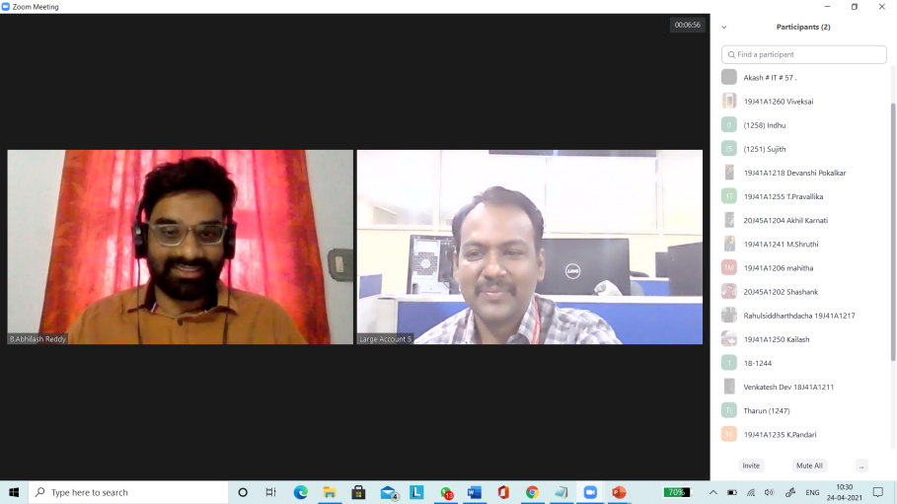
Photo Copy of the event | 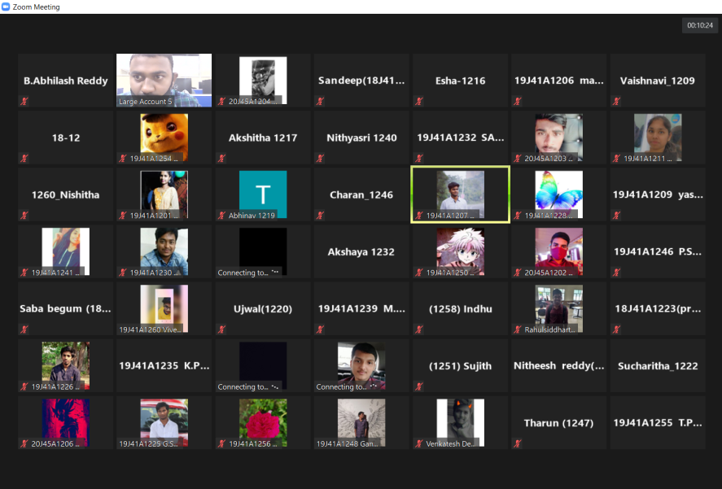

Coordinator HoD, CSE

